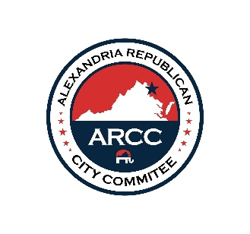

PRESS RELEASE
Contact: press@AlexGOP.org
October 10, 2025

Alexandria Republican City Committee issued the following statement regarding the Governor’s Race Debate held on October 9, 2025:

A hearty congratulations to Lt. Governor Winsome Earle-Sears on her outstanding debate performance. Earle-Sears was the clear winner of Thursday's debate and was relentless in trying to pin her opponent down for an answer on every issue. Her fortitude clearly rattled her opponent, leaving Spanberger either speechless or serving up extra portions of word salad when pressed for clarification by the moderators. Lt. Gov Earle-Sears was correct about her opponent when she said, “She has no courage.” As examples, Earle-Sears pointed out that her opponent has not asked Democrat Jay Jones to step down from the Attorney General race after the disqualifying revelations of his violent death wishes on a Republican family. Similarly, Spanberger has not called on Virginia’s two U.S. Senators to vote yes on the budget bill and end the government shutdown. Now that voters have had a chance to really compare the two candidates, they can see that Lt. Governor Winsome Earle-Sears will effectively continue the policies and successes of the Youngkin Administration, and Virginia will be the better for it.

The Alexandria GOP encourages all local commonsense voters to vote early, sign up for our e-news at www.AlexGOP.org, and volunteer with us at info@AlexGOP.org.

